Kringlecon Lessonized

Welcome to [Kringlecon](https://kringlecon.com/), a Capture the Flag (CTF) contest that is designed to entertain you and teach you penetration testing (pentest) and general IT security skills. Kringlecon has a series of excellent presentations designed to keep your pentest skills up to date. Some of the presentations even show you how to solve problems you will encounter in Kringlecon. These lessons will lead you through the CTF while highlighting and explaining the concepts behind the challenges.

It is very important to note that Kringlecon is available for free as a gift of [SANS](https://www.sans.org/security-resources/ipv6_tcpip_pocketguide.pdf) and CounterHack to the IT security world. Kringlecon offers a wide variety of practice for practitioners who may have to work in a small niche of the ITsec world during the rest of the year. It also introduces new techniques to people new to ITsec. Most of all, it lets us hack in a safe cyber range and have fun!

This year’s [Holiday Hack Challenge](https://holidayhackchallenge.com/) (HHC), Kringlecon, is about the same difficulty as last year’s [HHC 2017](https://holidayhackchallenge.com/past-challenges/). If the Kringlecon challenges are too much, give the [Lessonized version of the 2017](http://cardinalcybersec.com/holidayhack-lessonized) challenge a try! All HHC’s are maintained year-round for you ITsec education pleasure. If you ever run across Ed Skoudis or the CounterHack team, tell them thanks!

Note: These lessons are broken into small pieces to avoid giving spoilers away. If you are stuck go on to the next lesson, which will have the solution you need. The answers to all the HHC challenges are posted in many places on the Internet. If you want to get the most out of these lessons, avoid looking at the solutions on the Internet while doing the lessons.

# Introduction to Kringlecon

First, we’ll familiarize you with some of the basic aspects of the game. Go to <https://kringlecon.com/> and create an account. That should take you to the front gate of the conference location, Santa’s castle. You can personalize your avatar using the icons at the top right of the game.  
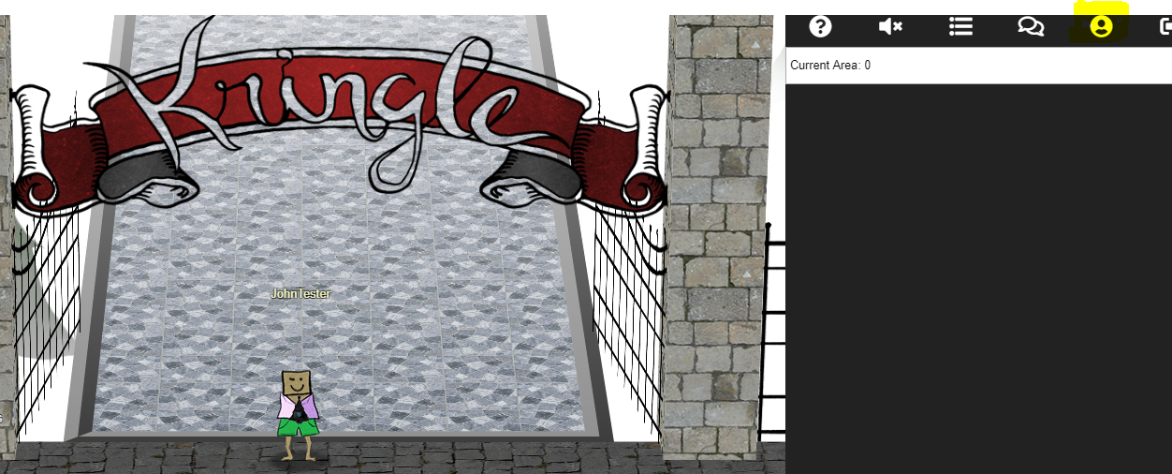

On the way in to the castle you will meet Santa, who has good advice if you click on him. In fact, you cannot enter the castle until you have talked to Santa. Here’s some good advice: if you forget what characters told you, click on the drop-down menu at the top right to see what they said.  
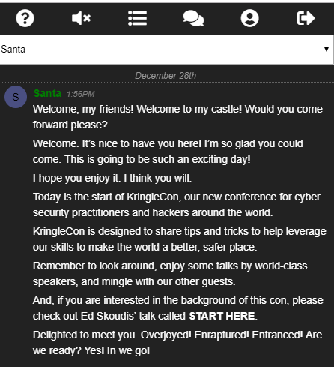

Your badge is a black Christmas tree-shaped icon on the front of your avatar. If you click it, you can see your objectives, hints from the characters, and other good information.  
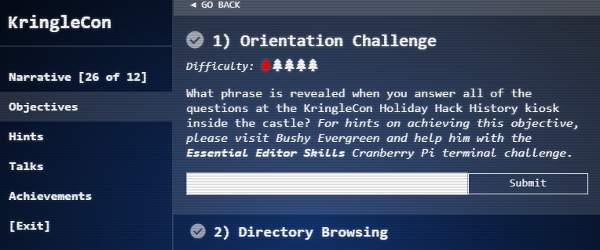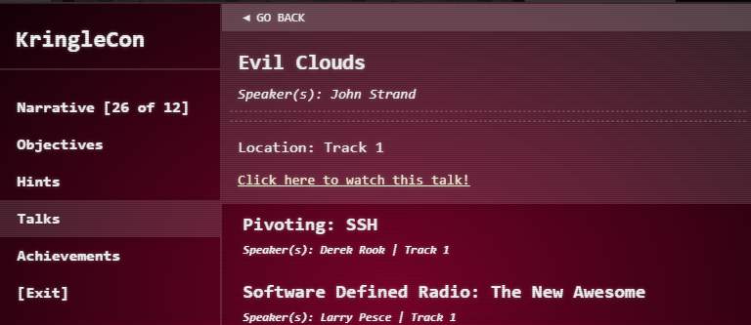

The list of talks is especially helpful--you can learn a lot about pentest techniques and IT security from these talks. Some of them have hints you need for the challenges, and others will be assigned as homework.

Once you enter the castle lobby, you will see several interesting things. Hans and the Toy Soldier are non-player characters (NPCs) that may have interesting things to say, but do not impact challenges. Normally, elves stand beside the terminals they manage. The elf may give you hints about how to solve the terminals. When you solve terminals, generally you receive more hints both in discussions with the elves (click on them) and in the Hints section of your badge.

The first challenge on your badge asks you to review the recent HHC history. To answer that challenge, you need to listen to a talk by Ed Skoudis, the originator of the HHC. It’s a cool talk, but if you are in a hurry to get on with the hacking, the flag you will receive if you answer the questions correctly is shown in the screenshot below.  
 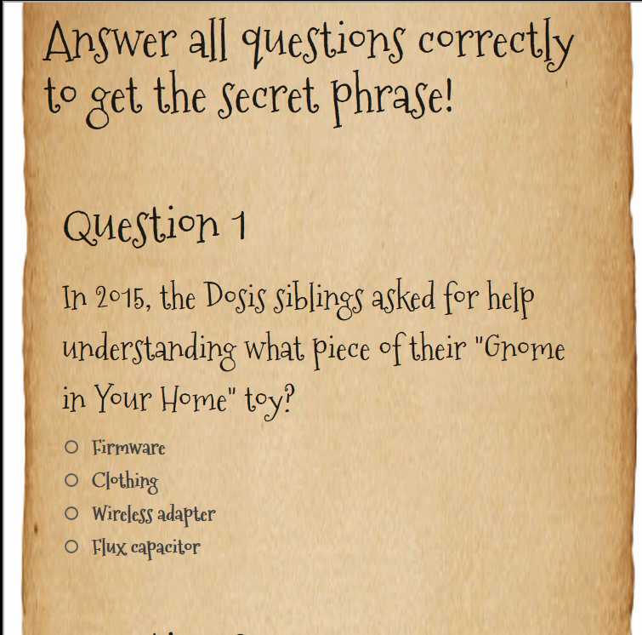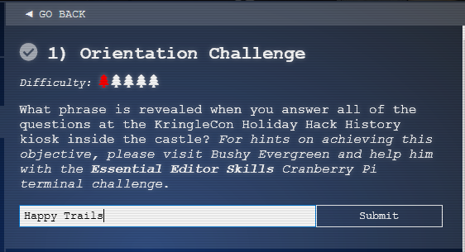

There’s one more thing we should look at to complete our tour--an elf terminal. Bushy Evergreen has a simple challenge for you to show you how terminals work.  
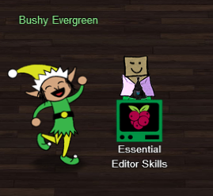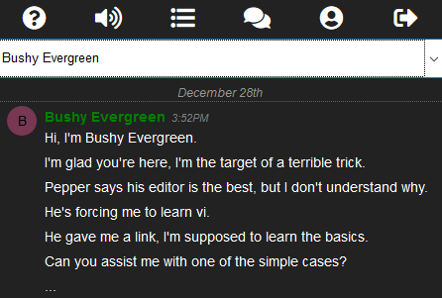

When you click on Bushy’s terminal Essential Editor Skills, you see this screen.  
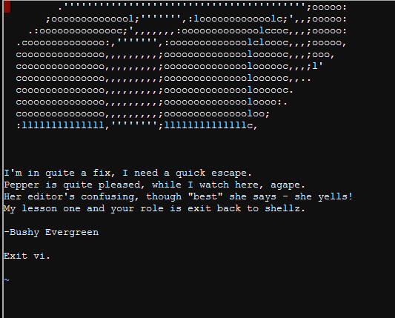

Show him how to exit vi; your favorite search engine will be helpful if you haven’t used vi before. When you do, the terminal will congratulate you and Bushy will have hints for you, if you click on him. In your badge you will see a hint from Bushy that gives this link: <https://kb.iu.edu/d/afcz>.   
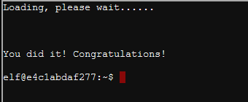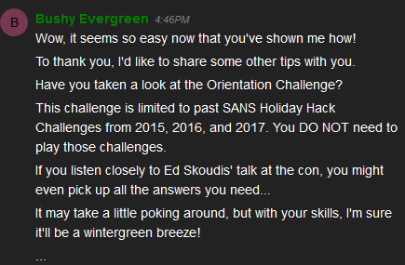

By the way, vi is one of the two famous console text editors that date back to the early Linux days (the other is EMACS.) It is amazingly powerful, with search, replace, cut, paste, and much more. It’s a little tricky, but if you are going to be using a Linux console it is good to know the basics of vi.

I guess we would have saved time if we had worked with Bushy first and found the link to Ed Skoudis talk first. Oh well. There should be two achievements on your badge now. We’ll move on to the next objective.  
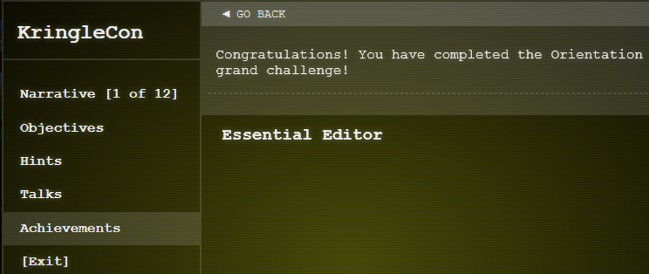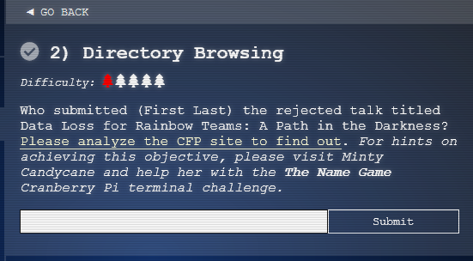

# Homework

Objective 2, Directory Browsing, suggests that you visit Minty Candycane for hints. Minty is on the other side of the lobby from Bushy. When you talk to Minty, she will explain the problem and two hints will appear in the Hints section of your badge; both are helpful links. (Note: Minty and the articles mention using the ‘&’ symbol. I had better luck without it.)

See if you can solve Minty’s terminal challenge without any further assistance.